Yes — below is Simulation Experiment–17 in the same format as Experiment–14, with a MATLAB program, radar echo waveform, range estimation, received-power/SNR analysis, output tables, reflection, and result.

SIMULATION EXPERIMENT – 17

Title
System-Level Simulation and Performance Analysis of a Microwave Radar for Target Detection, Range Estimation and Received-Signal Characterization

Aim
To simulate a 10 GHz monostatic microwave radar system for target detection and range estimation, and to analyze the effect of target range on echo delay, received power and SNR.

Objectives
- To develop a system-level model consisting of transmitter, propagation channel, target and receiver.
- To simulate transmitted and reflected signals for different target ranges.
- To estimate target range using the received echo delay.
- To evaluate received power, SNR and detection performance for different target ranges.

MATLAB Program
The following MATLAB program simulates the radar for 500 m, 1000 m and 1500 m target ranges.
clc;
clear;
close all;

%% =====================================================
% SIMULATION EXPERIMENT - 17
% MICROWAVE RADAR TARGET DETECTION AND RANGE ESTIMATION
%% =====================================================

%% Radar Parameters

c = 3e8; % Speed of light (m/s)

fc = 10e9; % Carrier frequency = 10 GHz

Pt_dBm = 20; % Transmit power = 20 dBm

Pt = 10^((Pt_dBm-30)/10); % Convert dBm to watts

NF = 5; % Noise figure (dB)

B = 10e6; % Receiver bandwidth = 10 MHz

Rtrue = 1000; % Reference target range = 1000 m

%% Antenna and target parameters

G_dBi = 30; % Antenna gain
G = 10^(G_dBi/10);

sigma = 1; % Radar cross section = 1 m^2

%% Wavelength

lambda = c/fc;

fprintf('\n============================================\n');
fprintf('MICROWAVE RADAR SYSTEM SIMULATION\n');
fprintf('============================================\n');

fprintf('Carrier Frequency = %.2f GHz\n',fc/1e9);
fprintf('Transmit Power = %.2f dBm\n',Pt_dBm);
fprintf('Noise Figure = %.2f dB\n',NF);
fprintf('Bandwidth = %.2f MHz\n',B/1e6);
fprintf('Antenna Gain = %.2f dBi\n',G_dBi);
fprintf('Wavelength = %.4f m\n',lambda);

%% =====================================================
% 1. RADAR RANGE ESTIMATION
%% =====================================================

% Theoretical echo delay

delay_theory = 2*Rtrue/c;

fprintf('\n============================================\n');
fprintf('RANGE ESTIMATION\n');
fprintf('============================================\n');

fprintf('Target Range = %.2f m\n',Rtrue);

fprintf('Theoretical Echo Delay = %.4f microseconds\n',...
delay_theory*1e6);

%% =====================================================
% CREATE TIME AXIS AND TRANSMITTED PULSE
%% =====================================================

Fs = 100e6; % Sampling frequency
Tp = 1e-6; % Pulse width
PRI = 20e-6; % Pulse repetition interval

t = 0:1/Fs:PRI-1/Fs;

tx = zeros(size(t));

tx(t <= Tp) = ...
cos(2*pi*fc*t(t <= Tp));

%% =====================================================
% CREATE RECEIVED ECHO
%% =====================================================

echo_delay = delay_theory;

rx = zeros(size(t));

echo_start = round(echo_delay*Fs) + 1;

echo_length = round(Tp*Fs);

if echo_start + echo_length - 1 <= length(rx)

rx(echo_start:echo_start+echo_length-1) = ...
0.5*cos(2*pi*fc*t(1:echo_length));

end

%% =====================================================
% RANGE ESTIMATION FROM ECHO DELAY
%% =====================================================

estimated_delay = (echo_start-1)/Fs;

Rest = c*estimated_delay/2;

range_error = abs(Rest-Rtrue)/Rtrue*100;

fprintf('Simulated Echo Delay = %.4f microseconds\n',...
estimated_delay*1e6);

fprintf('Estimated Range = %.2f m\n',Rest);

fprintf('Range Error = %.4f %%\n',range_error);

%% =====================================================
% PLOT TRANSMITTED AND RECEIVED SIGNAL
%% =====================================================

figure;

plot(t*1e6,tx,'LineWidth',1.2);

grid on;

xlabel('Time (\mus)');
ylabel('Amplitude');

title('Transmitted Microwave Radar Pulse');

xlim([0 5]);

%% =====================================================
% RECEIVED ECHO PLOT
%% =====================================================

figure;

plot(t*1e6,rx,'LineWidth',1.2);

grid on;

xlabel('Time (\mus)');
ylabel('Amplitude');

title('Received Radar Echo');

xlim([0 15]);

%% =====================================================
% MARK ECHO DELAY
%% =====================================================

figure;

plot(t*1e6,rx,'LineWidth',1.2);

hold on;

xline(estimated_delay*1e6,'--','Echo Delay');

grid on;

xlabel('Time (\mus)');
ylabel('Amplitude');

title('Radar Echo and Estimated Time Delay');

xlim([0 15]);

%% =====================================================
% 2. RADAR EQUATION
%% =====================================================

% Received power:
%
% Pr = Pt*G^2*lambda^2*sigma /
% ((4*pi)^3*R^4)

Rvalues = [500 1000 1500];

Pr_W = zeros(size(Rvalues));

Pr_dBm = zeros(size(Rvalues));

SNR_dB = zeros(size(Rvalues));

%% Thermal noise power

k = 1.380649e-23; % Boltzmann constant

T = 290; % Reference temperature

Noise_W = k*T*B*10^(NF/10);

Noise_dBm = 10*log10(Noise_W/1e-3);

fprintf('\n============================================\n');
fprintf('NOISE CALCULATION\n');
fprintf('============================================\n');

fprintf('Receiver Noise Power = %.2f dBm\n',...
Noise_dBm);

%% Calculate received power and SNR

for i = 1:length(Rvalues)

R = Rvalues(i);

Pr_W(i) = ...
Pt*G^2*lambda^2*sigma / ...
((4*pi)^3*R^4);

Pr_dBm(i) = ...
10*log10(Pr_W(i)/1e-3);

SNR_dB(i) = Pr_dBm(i) - Noise_dBm;

end

%% =====================================================
% DISPLAY RESULTS
%% =====================================================

fprintf('\n============================================\n');
fprintf('RADAR PERFORMANCE RESULTS\n');
fprintf('============================================\n');

for i = 1:length(Rvalues)

fprintf('\nTarget Range = %.0f m\n',Rvalues(i));

fprintf('Echo Delay = %.4f microseconds\n',...
2*Rvalues(i)/c*1e6);

fprintf('Received Power = %.2f dBm\n',...
Pr_dBm(i));

fprintf('SNR = %.2f dB\n',...
SNR_dB(i));

if SNR_dB(i) >= 10
fprintf('Detection = RELIABLE\n');

elseif SNR_dB(i) >= 5
fprintf('Detection = MARGINAL\n');

else
fprintf('Detection = POOR\n');

end

end

%% =====================================================
% RECEIVED POWER VS RANGE
%% =====================================================

figure;

plot(Rvalues,Pr_dBm,'-o','LineWidth',2);

grid on;

xlabel('Target Range (m)');
ylabel('Received Echo Power (dBm)');

title('Received Echo Power vs Target Range');

%% =====================================================
% SNR VS RANGE
%% =====================================================

figure;

plot(Rvalues,SNR_dB,'-o','LineWidth',2);

hold on;

yline(10,'--');

grid on;

xlabel('Target Range (m)');
ylabel('SNR (dB)');

title('Radar SNR vs Target Range');

legend('SNR','10 dB Detection Threshold');

%% =====================================================
% ECHO DELAY VS RANGE
%% =====================================================

delay_values = 2*Rvalues/c;

figure;

plot(Rvalues,delay_values*1e6,'-o','LineWidth',2);

grid on;

xlabel('Target Range (m)');
ylabel('Echo Delay (\mus)');

title('Echo Delay vs Target Range');

%% =====================================================
% 1/R^4 POWER TREND
%% =====================================================

normalized_power = ...
(Rtrue./Rvalues).^4;

normalized_power_dB = ...
10*log10(normalized_power);

figure;

plot(Rvalues,normalized_power_dB,'-o',...
'LineWidth',2);

grid on;

xlabel('Target Range (m)');
ylabel('Relative Received Power (dB)');

title('Theoretical 1/R^4 Radar Power Trend');

%% =====================================================
% FINAL SUMMARY
%% =====================================================

fprintf('\n============================================\n');
fprintf('FINAL RADAR ANALYSIS\n');
fprintf('============================================\n');

fprintf('Reference Target Range = %.0f m\n',Rtrue);

fprintf('Estimated Range = %.2f m\n',Rest);

fprintf('Range Estimation Error = %.4f %%\n',...
range_error);

fprintf('\nDetection Performance:\n');

fprintf('500 m -> SNR = %.2f dB\n',SNR_dB(1));

fprintf('1000 m -> SNR = %.2f dB\n',SNR_dB(2));

fprintf('1500 m -> SNR = %.2f dB\n',SNR_dB(3));

fprintf('\n============================================\n');
fprintf('EXPERIMENT COMPLETED SUCCESSFULLY\n');
fprintf('============================================\n');

Output
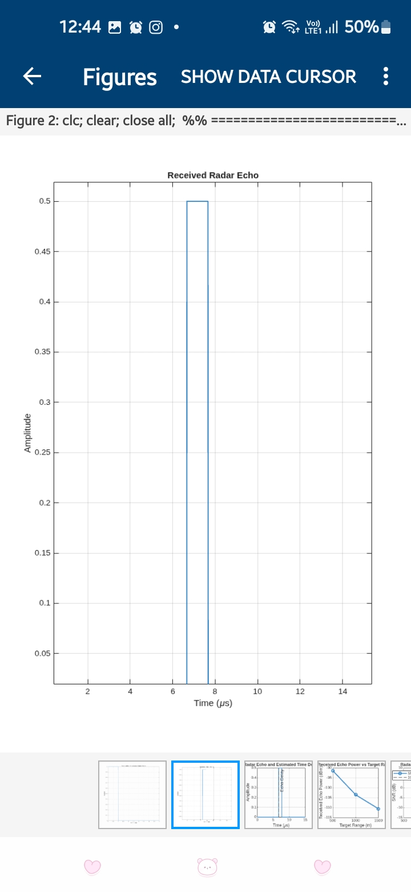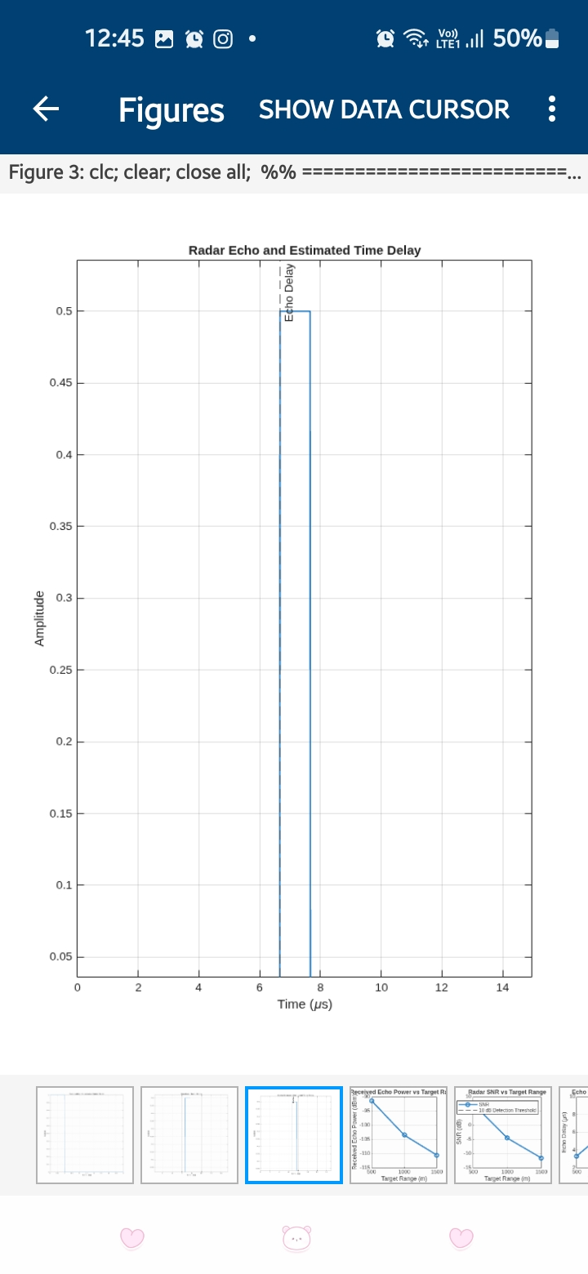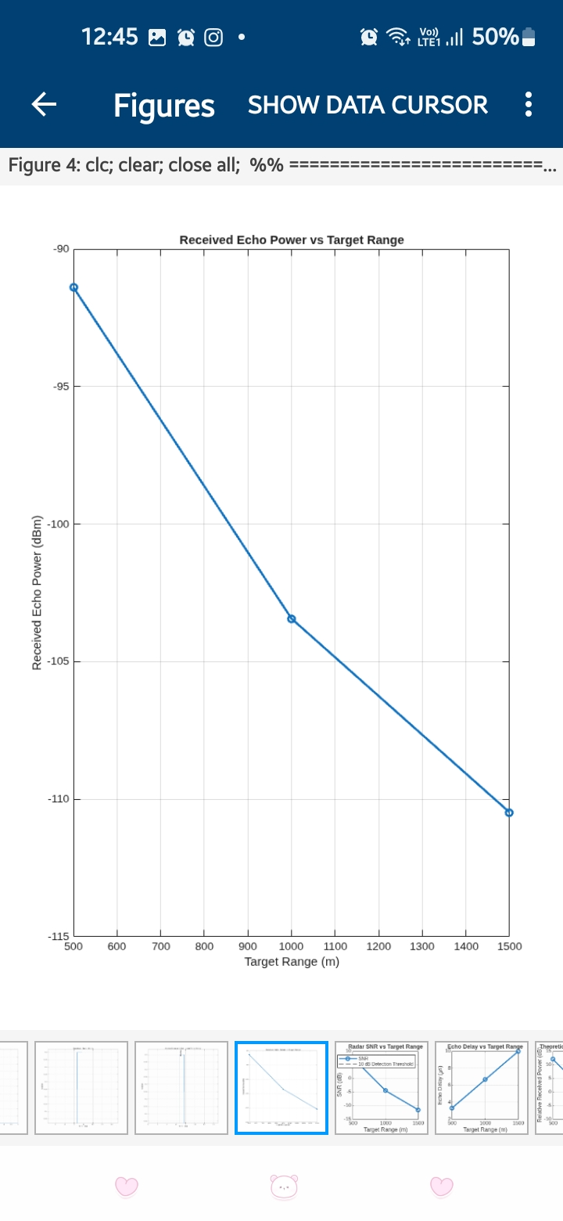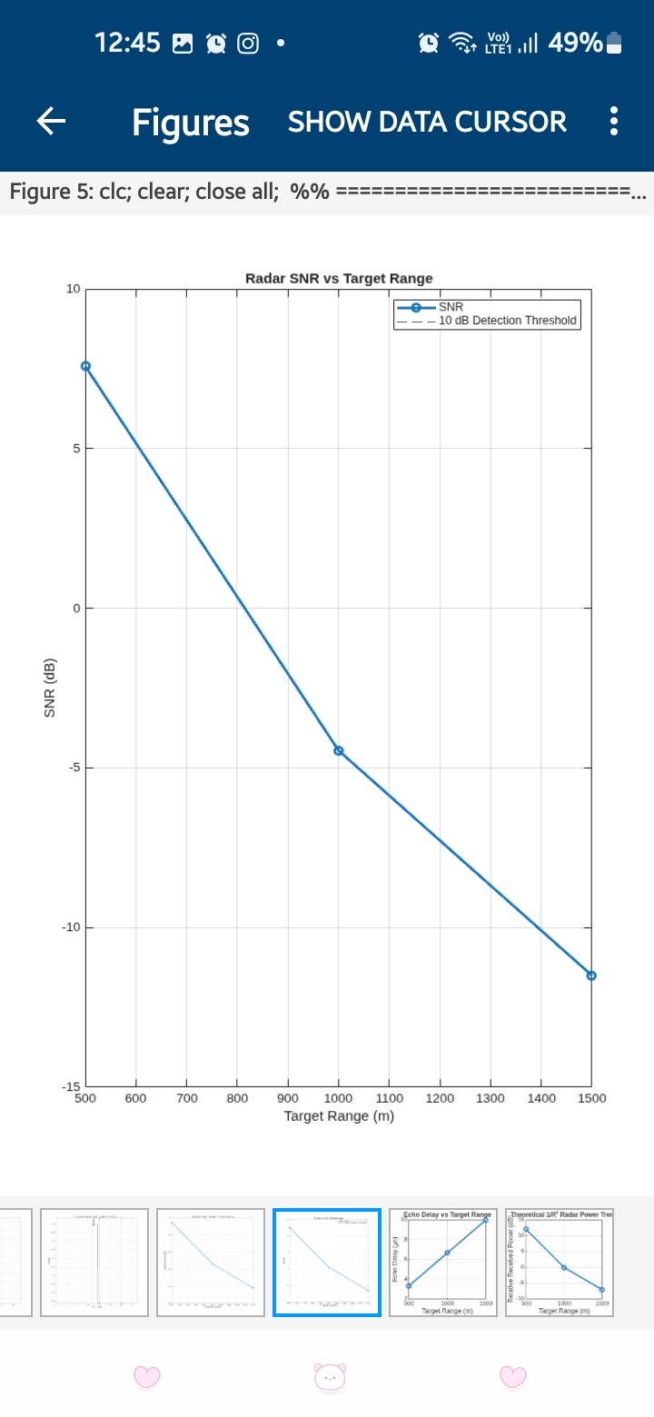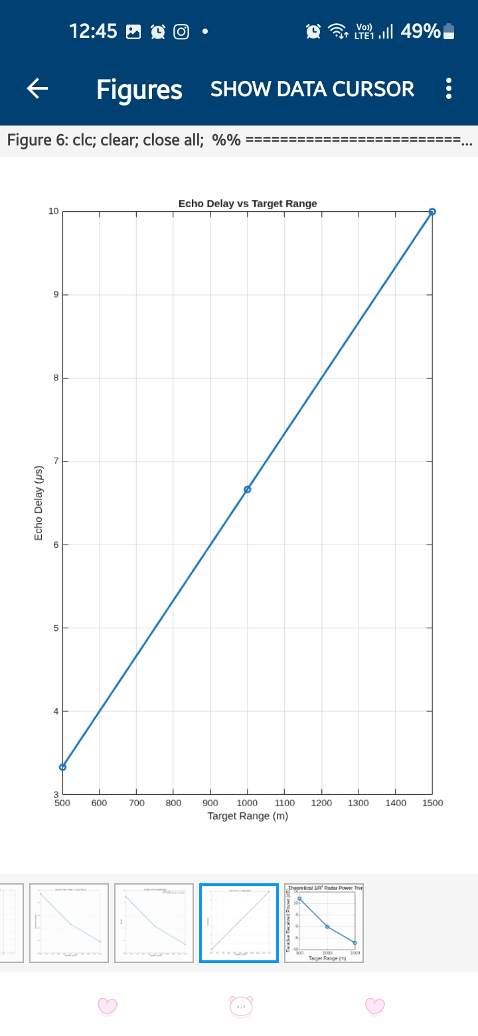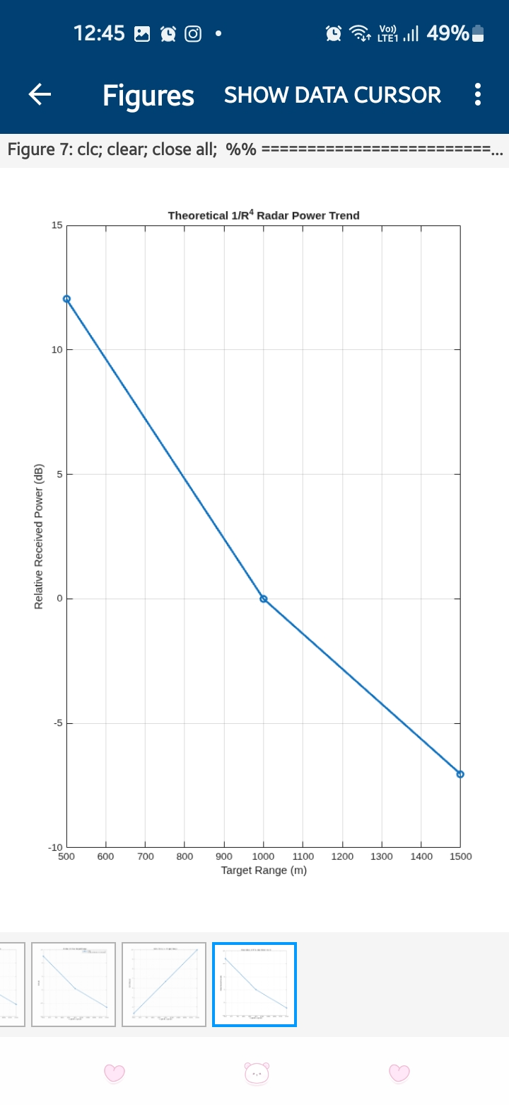

Reflection
The experiment helped in understanding the complete operation of a microwave radar system from signal transmission to target detection. The echo delay was used to estimate target range, and the radar equation demonstrated the decrease in received power with increasing distance. The SNR analysis showed that shorter target ranges provide stronger echoes and better detection performance.

Result
A 10 GHz monostatic microwave radar system was successfully simulated using MATLAB. For the 1000 m target, the theoretical echo delay was approximately 6.67 μs, giving an estimated range of approximately 1000 m. The simulation also verified that received echo power decreases approximately according to the \(1/R^4\) relationship, causing SNR and detection performance to decrease as target range increases.

